This query performs a Pivot counts into a Customer Retention Matrix

QUERY -;
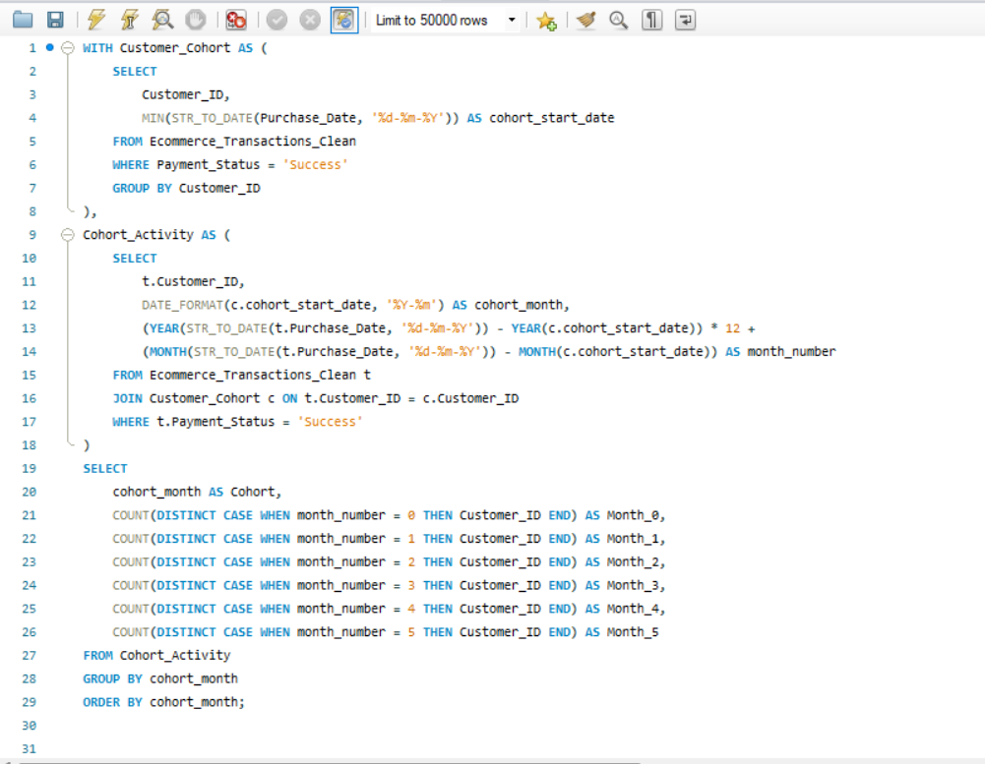

OUTPUT-;
